Service Contract

cs.pay.ebs.Bills_1.0

Author: Marwan Zakhia

Creation Date: April 22, 2015

Last Updated: April 22, 2015

Version: 0.1 - Draft

1. **Title, Subject, Last Updated Date, Reference Number**, **and** **Version** are marked by a Word Bookmark so that they can be easily reproduced in the header and footer of documents. When you change any of these values, be careful not to accidentally delete the bookmark. **You can make bookmarks visible by selecting Tools->Options…View and checking the Bookmarks option in the Show region.**

**Approvals:**

|  |  |
| --- | --- |
| Mohammad Abumalloh |  |
| Osama AlDameri |  |

1. To add additional approval lines, press [Tab] from the last cell in the table above.
2. You can delete any elements of this cover page that you do not need for your document.

# Document Control

## Change Record

4

| Date | Author | Version | Change Reference |
| --- | --- | --- | --- |
| 14-April-2015 | Marwan Zakhia | 0.1 | Initial or Draft Version |
|  |  |  |  |
|  |  |  |  |

## Reviewers

| Name | Position |
| --- | --- |
| Mohammad Abumalloh | SBM Project Manager |
| Osama Al Dameri | EMAD Project Manager |
|  |  |
|  |  |

Contents

Document Control 2

Change Record 2

Reviewers 2

Introduction 4

Purpose 4

Intended Audience 4

Document Summary 4

Document References 4

Assumptions and Constraints 4

Non-Functional Details 4

Overview Of operations 1

Interface Definition 2

Operation – uploadBill 3

Expected Errors 2

Operation –loadBill 3

Expected Errors 2

Operation – confirmBill 4

Expected Errors 2

Appendix 3

1. To update the table of contents, put the cursor anywhere in the table and press [F9]. To change the number of levels displayed, select the menu option Insert‑>Index and Tables, make sure the Table of Contents tab is active, and change the Number of Levels to a new value.

# Introduction

The purpose of this task is to assemble all the information that is required to describe the design of a software component into a complete Design Specification. This task is not a substitute for executing the individual design tasks. This specification work product can serve as a structure for completing the design for each component by providing pointers back into the Design Tasks:   
- DS.040 Develop Design Architecture Description  
- DS.080 Design Software Components  
- DS.090 Design Data  
- DS.100 Design Behavior  
- DS.130 Design User Interface

## Purpose

The purpose of this document is to serve as a description of the capabilities offered by the service as well as the requirements placed on the client by the service e.g. security requirements. It also provides, at a high level, the technical solution. This document will describe both the functional and non-functional aspects of the service. This document will not describe the technical aspects of the service. This information can be viewed in the Technical Specification for the service.

## Intended Audience

The intended audience for this document is:

* Architects
* Developers
* Testers

## Document Summary

This document is produced after service identification and documentation thereof in the solution blueprint.

This document covers the following areas:

* Service Description
* Service Design & High Level Implementation details
* WSDL
* Enterprise Business Messages (EBM)

## Document References

The following documents were considered in the authoring of this service contract:

* Solution Blueprint Document
* SADAD integration Document

## Assumptions and Constraints

* The provider system is assumed to be accurate in its responses
* The provider system is considered to be stable
* Service availability is constrained by the availability of the provider system

## Non-Functional Details

### General Properties

|  |  |
| --- | --- |
| **Service Name** | Bills |
| **Service Type** | External Business Service (EBS) |
| **Capability** | cs.pay |
| **Function** | Provide access to bills details and functions. |
| **Critical Dependencies** | The provider system provides timely access to accurate transaction information |
| **Dependencies on Other SOA Services** | None |
| **Other Dependencies** | The provider system |

### Quality of Service

| **Availability** | 24 hours a day, 7 days a week |
| --- | --- |
| **Reliability** | Not Applicable |
| **Throughput** | Up to approximately 5kB of data in the given response time for a search |
| **Response time** | uploadBill < 20 seconds  loadBill < 10 seconds  confirmBill < 10 seconds |

## Overview Of operations

| **Operation** | **Description** | **Communication Style** | **Inputs** | **Outputs** | **Expected Errors** |
| --- | --- | --- | --- | --- | --- |
| uploadBill | Upload a batch of bills to Sadad. | Acknowledge Synchronous Request - Response | Bills Info | Acknowledge flagss | Invalid request data  Provider system communication errors  Provider system functional errors  Unexpected IT related errors |
| loadBill | Upload bills to a sadad in real time transaction | Synchronous Request - Response | Bill Info | Satus code  Error code  Error message | Invalid request data  Provider system communication errors  Provider system functional errors  Unexpected IT related errors |
| confirmBill | Provides a Bill Load Summary report and a list of rejected records | Synchronous Request - Response | Success record counts  Error records count | Acknowledge flags | Invalid request data  Provider system communication errors  Provider system functional errors  Unexpected IT related errors |

## Interface Definition

### WSDL

The service interface definition in graphical WSDL format is presented below in Figure 1.

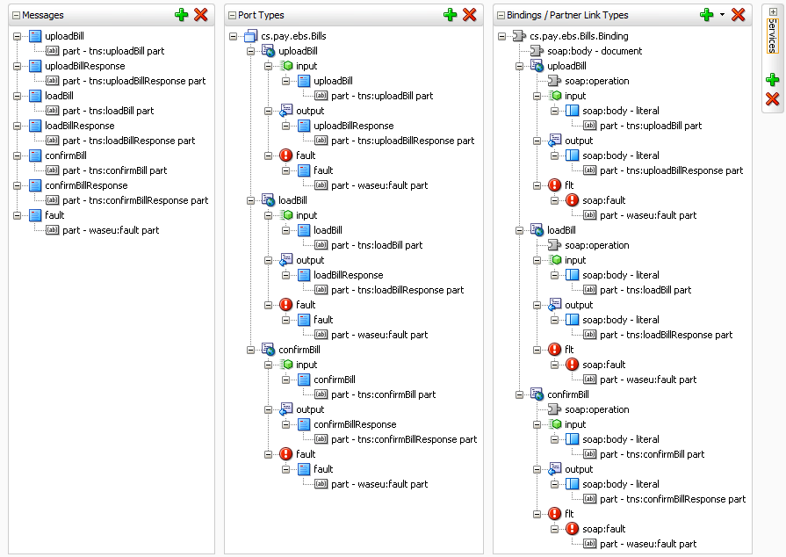

Figure 1 – Service Interface WSDL

## Operation – uploadBill

### Overview

| **Communication Style** | Acknowledge Synchronous request-response |
| --- | --- |
| **CRUD Operation/s** | Update |
| **Idempotent** | Yes |
| **Atomic** | Yes |
| **Transaction Required** | No |
| **Transaction Coordination Required** | N/A |
| **How Transaction Coordination Achieved** | N/A |

### Functional Overview



Figure 2: Functional Overview

### Security

The consumer will provide credentials enabling the consumer to consume the *uploadBill* operation using Client Certificate Authentication over TLS.

### Input EBM

The input EBM is ***uploadBill*** and is in the XML namespace ***http://www.AlMajdouie.sa/ebs/cs.pay.Bills***. The figure below depicts this message.

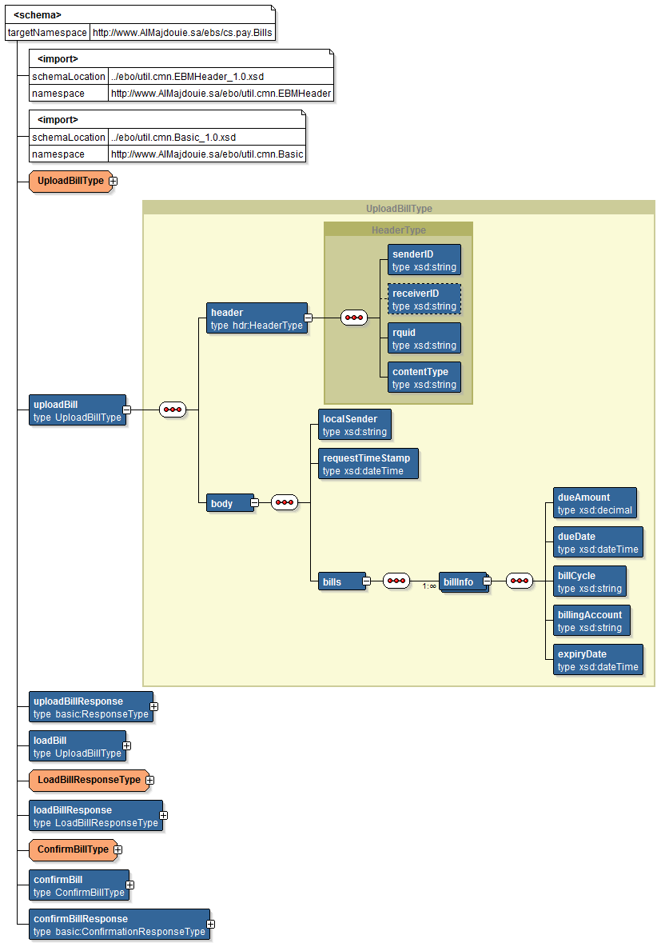

Figure 3: uploadBills input EBM

### Output EBM

The output EBM is ***uploadBillResponse*** and is in the XML namespace ***http://www.AlMajdouie.sa/ebs/cs.pay.Bills***. The figure below depicts this message.

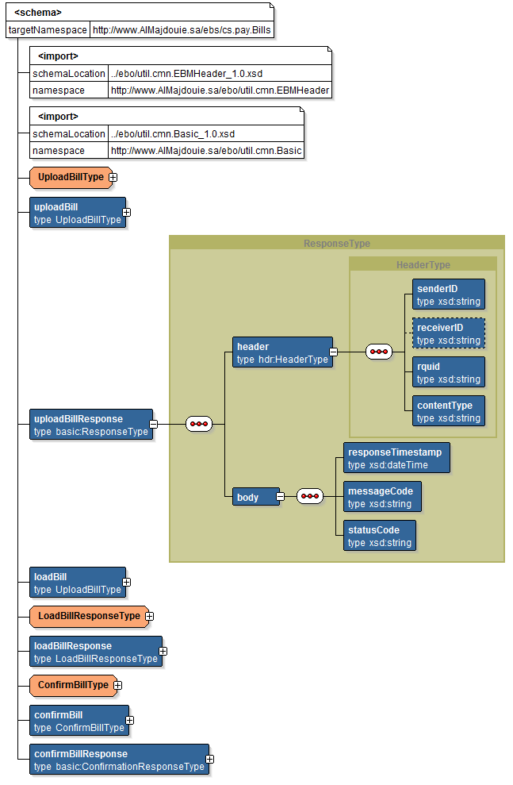

Figure 4: uploadBillsResponse output EBM

### Fault EBM

The fault EBM is ***fault*** and is in the XML namespace ***http://www.AlMajdouie.sa/ebo/util.flt.Fault***. The figure below depicts this message.

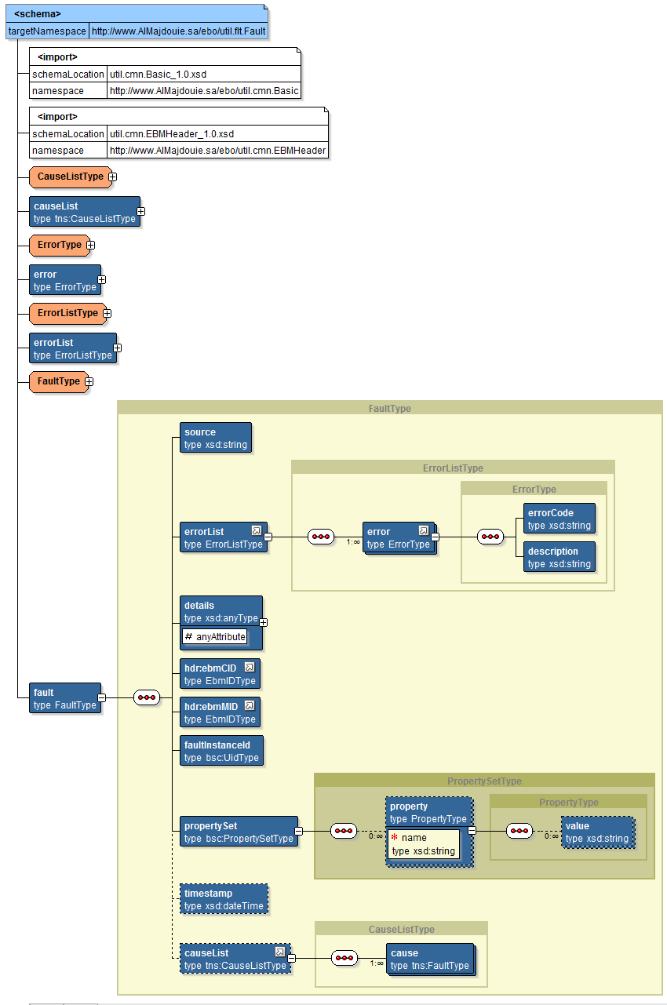

Figure 5: fault EBM

## Expected Errors

### Business Errors

| **Error Source** | **Error** | **Error Code Returned** | **Message Returned** | **Cause List** |
| --- | --- | --- | --- | --- |
| SOA | Unsupported operation | cs.pay:100 | Requested operation not found or supported | *Cause list not populated* |
| XQuery failure | cs.pay:400 | XQuery failure | *Cause list not populated* |
| Insert failure | cs.pay:401 | Insert failure | *Cause list not populated* |
| XML parsing error | cs.pay:402 | Failed to parse XML text | *Cause list not populated* |
| Context variable error | cs.pay:403 | Failed to set the value of context variable | *Cause list not populated* |
| Validation | Invalid request message | cs.pay:500 | Request message schema validation error | *Cause list not populated* |
| Invalid response message | cs.pay:501 | Response message schema validation error | *Cause list not populated* |
| Provider System | Missing / Invalid sender-id or rquid | cs.pay:900 | Invalid or missing HTTP Header sender-id or rquid | *Cause list not populated* |
| Missing Data | cs.pay:901 | Missing data stream or invalid content-type application/octet-stream | *Cause list not populated* |
| Invalid Message Code | cs.pay:902 | Invalid message code. Expected BUPLQ | *Cause list not populated* |
| Invalid message type | cs.pay:903 | Invalid message type. Expected BillUploadRq | *Cause list not populated* |
| Internal Error | cs.pay:998 | Internal error has occurred | *Cause list not populated* |
| Unexpected error | cs.pay:999 | Unexpected error in the provider system. | *Cause list not populated* |

### System Errors

| **Error Source** | **Error** | **Error Code Returned** | **Message Returned** | **Cause List** |
| --- | --- | --- | --- | --- |
| Network | Communication errors | cs.pay:200 | External transport error communicating with a provider. | *Cause list not populated* |
| Policy | Security policy fails | cs.pay:300 | Security policy failure. Ensure correct credentials are provided. | *Cause list not populated* |

### All Other Errors

| **Error** | **Error Code Returned** | **Message Returned** | **Cause List** |
| --- | --- | --- | --- |
| All other errors | cs.pay:001 | An unexpected error occurred | *Cause list not populated* |

## Operation –loadBill

### Overview

| **Communication Style** | Synchronous request-response |
| --- | --- |
| **CRUD Operation/s** | Update |
| **Idempotent** | Yes |
| **Atomic** | Yes |
| **Transaction Required** | No |
| **Transaction Coordination Required** | N/A |
| **How Transaction Coordination Achieved** | N/A |

### Functional Overview



Figure 6: Functional Overview

### Security

The consumer will provide credentials enabling the consumer to consume the *loadBill* operation using Client Certificate Authentication over TLS.

### Input EBM

The input EBM is ***loadBills*** and is in the XML namespace ***http://www.AlMajdouie.sa/ebs/cs.pay.Bills***. The figure below depicts this message.

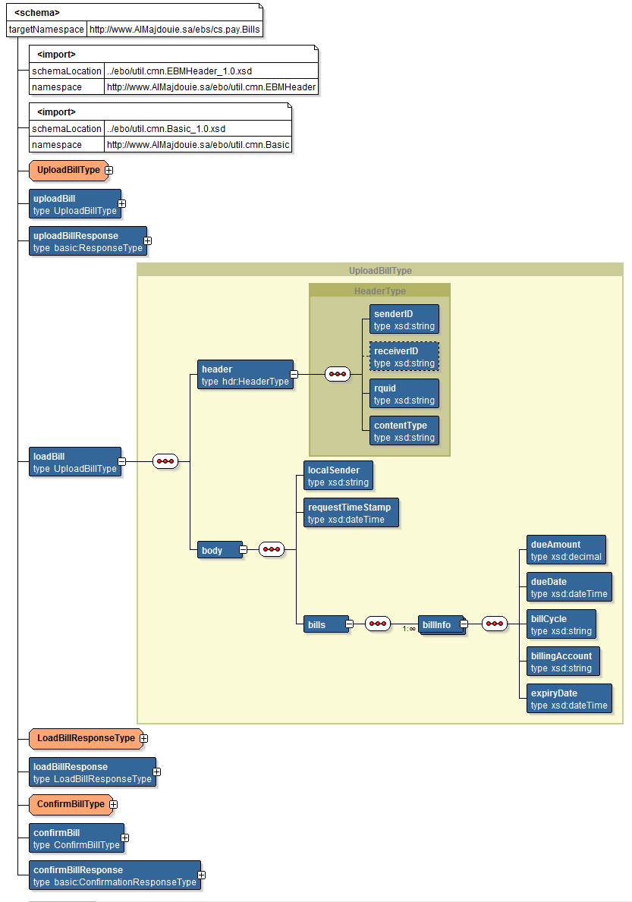

Figure 7: uploadBills input EBM

### Output EBM

The output EBM is ***loadBillsResponse*** and is in the XML namespace ***http://www.AlMajdouie.sa/ebs/cs.pay.Bills***. The figure below depicts this message.

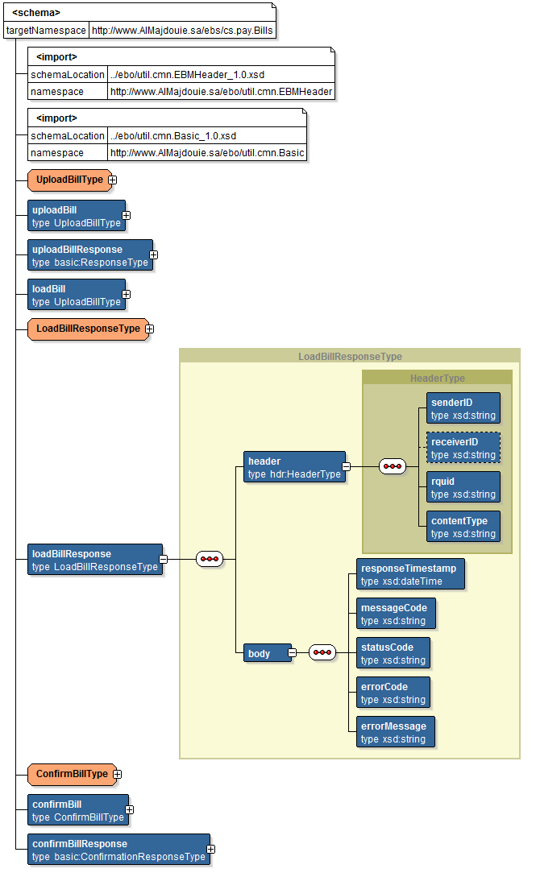

Figure 8: loadBillsResponse output EBM

### Fault EBM

The fault EBM is ***fault*** and is in the XML namespace ***http://www.AlMajdouie.sa/ebs/cs.pay.Bills***. The figure below depicts this message.



Figure 5: fault EBM

## Expected Errors

### Business Errors

| **Error Source** | **Error** | **Error Code Returned** | **Message Returned** | **Cause List** |
| --- | --- | --- | --- | --- |
| SOA | Unsupported operation | cs.pay:100 | Requested operation not found or supported | *Cause list not populated* |
| XQuery failure | cs.pay:400 | XQuery failure | *Cause list not populated* |
| Insert failure | cs.pay:401 | Insert failure | *Cause list not populated* |
| XML parsing error | cs.pay:402 | Failed to parse XML text | *Cause list not populated* |
| Context variable error | cs.pay:403 | Failed to set the value of context variable | *Cause list not populated* |
| Validation | Invalid request message | cs.pay:500 | Request message schema validation error | *Cause list not populated* |
| Invalid response message | cs.pay:501 | Response message schema validation error | *Cause list not populated* |
| Provider System | Missing / Invalid sender-id or rquid | cs.pay:900 | Invalid or missing HTTP Header sender-id or rquid | *Cause list not populated* |
| Missing Data | cs.pay:901 | Missing data stream or invalid content-type application/octet-stream | *Cause list not populated* |
| Invalid Message Code | cs.pay:902 | Invalid message code. Expected BUPLQ | *Cause list not populated* |
| Invalid message type | cs.pay:903 | Invalid message type. Expected BillUploadRq | *Cause list not populated* |
| Invalid Amount | cs.pay:910 | The amount due is invalid | *Cause list not populated* |
| Invalid due date | cs.pay:911 | Due date is not in acceptable format | *Cause list not populated* |
| Invalid open Date | cs.pay:912 | Open date is not in acceptable format | *Cause list not populated* |
| Invalid Close Date | cs.pay:913 | Close date is not in acceptable format | *Cause list not populated* |
| Invalid Payment Status effective date | cs.pay:914 | Payment Status Effective Date for Payment Id [pmtId] is Invalid | *Cause list not populated* |
| Invalid Payment Status Current Ammount | cs.pay:915 | Payment Status Current Amount is Invalid for Payment Id | *Cause list not populated* |
| Invalid Service Type | cs.pay:916 | Invalid Service Type for Account number{account number} | *Cause list not populated* |
| Invalid Category Code | cs.pay:917 | Invalid Category Code for the Account number{account number} | *Cause list not populated* |
| Account Deactive | cs.pay:918 | The Account is Deactivated | *Cause list not populated* |
| Upload error | cs.pay:919 | Payment Upload Error(s) | *Cause list not populated* |
| Bill already exists | cs.pay:920 | Active Bill already exists for the Bill Cycle | *Cause list not populated* |
| Invalid Bill Status Code | cs.pay:921 | Invalid Bill Status Code | *Cause list not populated* |
| Bill Cycle does not exist | cs.pay:922 | Bill Cycle does not exist | *Cause list not populated* |
| Invalid Expiry Date | cs.pay:923 | Expiry date is not in acceptable format | *Cause list not populated* |
| Invalid active normal bill | cs.pay:924 | No active normal bill exists for this high toll bill | *Cause list not populated* |
| Payment completion failed | cs.pay:925 | Payment completion failed | *Cause list not populated* |
| Internal Validation Error | cs.pay:926 | Internal Validation Error (e.g. duplicate statement, etc.) | *Cause list not populated* |
| Duplicate Statement | cs.pay:927 | Duplicate Statement | *Cause list not populated* |
| Deactivated Service type | cs.pay:928 | Deactivated Service Type for Account Number | *Cause list not populated* |
| Deactivated Category | cs.pay:929 | Deactivated Category for the Account Number | *Cause list not populated* |
| Invalid Bill Identification Rule | cs.pay:930 | Bill Identification Rule does not exist for the category | *Cause list not populated* |
| Invalid statement number | cs.pay:931 | Statement with same number already exists for the merchant | *Cause list not populated* |
| Invalid New one-off bill | cs.pay:932 | New one-off bill already exists for the category | *Cause list not populated* |
| Invalid Bill Number | cs.pay:933 | Bill number does not exist | *Cause list not populated* |
| Invalid Recurring category | cs.pay:934 | Recurring category already exists for the category Number XXXXX | *Cause list not populated* |
| Invalid currency value | cs.pay:935 | Minimum partial payment amount is not a valid currency value | *Cause list not populated* |
| Invalid currency value | cs.pay:936 | Minimum advance payment amount is not a valid currency value | *Cause list not populated* |
| Invalid currency value | cs.pay:937 | Maximum advance payment amount is not a valid currency value | *Cause list not populated* |
| Duplicate RqUID | cs.pay:938 | Duplicate RqUID, file not processed | *Cause list not populated* |
| Invalid Bill | cs.pay:939 | A newer version of the corresponding bill already exists in the system | *Cause list not populated* |
| Invalid state | cs.pay:940 | One or more payments associated with the statement couldn’t be completed due to invalid state | *Cause list not populated* |
| Payments Cancelled | cs.pay:941 | One or more payments cancelled after generating this statement | *Cause list not populated* |
| Payment Reversed | cs.pay:942 | One or more payments reversed after generating this statement | *Cause list not populated* |
| Internal Error | cs.pay:998 | Internal error has occurred | *Cause list not populated* |
| Unexpected error | cs.pay:999 | Unexpected error in the provider system. | *Cause list not populated* |

### System Errors

| **Error Source** | **Error** | **Error Code Returned** | **Message Returned** | **Cause List** |
| --- | --- | --- | --- | --- |
| Network | Communication errors | cs.pay:200 | External transport error communicating with a provider. | *Cause list not populated* |
| Policy | Security policy fails | cs.pay:300 | Security policy failure. Ensure correct credentials are provided. | *Cause list not populated* |

### All Other Errors

| **Error** | **Error Code Returned** | **Message Returned** | **Cause List** |
| --- | --- | --- | --- |
| All other errors | cs.pay:001 | An unexpected error occurred | *Cause list not populated* |

## Operation – confirmBill

### Overview

| **Communication Style** | Synchronous request-response |
| --- | --- |
| **CRUD Operation/s** | read |
| **Idempotent** | Yes |
| **Atomic** | Yes |
| **Transaction Required** | No |
| **Transaction Coordination Required** | N/A |
| **How Transaction Coordination Achieved** | N/A |

### Functional Overview



Figure 6: Functional Overview

### Security

The consumer will provide credentials enabling the consumer to consume the *confirmBill* operation using Client Certificate Authentication over TLS.

### Input EBM

The input EBM is ***confirmBill*** and is in the XML namespace ***http://www.AlMajdouie.sa/ebs/cs.pay.Bills***. The figure below depicts this message.

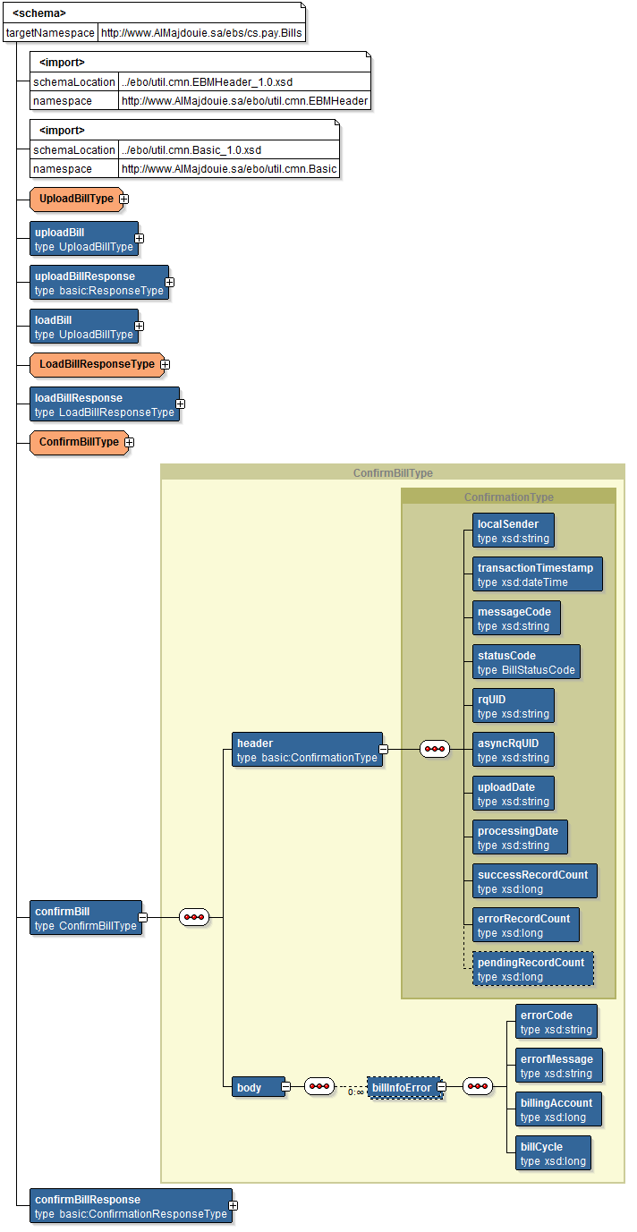

Figure 6: confirmBill input EBM

### Output EBM

The output EBM is ***confirmBillResponse*** and is in the XML namespace ***http://www.AlMajdouie.sa/ebs/cs.pay.Bills***. The figure below depicts this message.

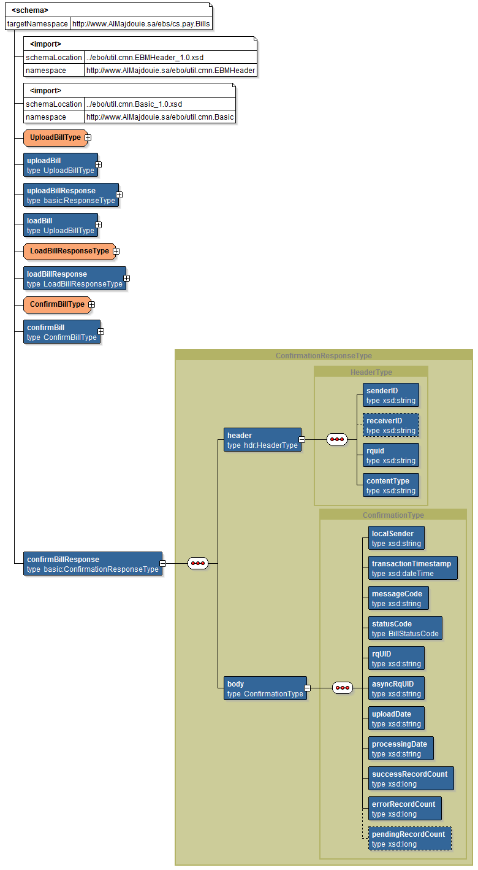

Figure 7: confirmBillResponse output EBM

### Fault EBM

The fault EBM is ***fault*** and is in the XML namespace ***http://www.AlMajdouie.sa/ebo/util.flt.Fault***. The figure below depicts this message.



Figure 8: fault EBM

## Expected Errors

### Business Errors

| **Error Source** | **Error** | **Error Code Returned** | **Message Returned** | **Cause List** |
| --- | --- | --- | --- | --- |
| SOA | Unsupported operation | cs.pay:100 | Requested operation not found or supported | *Cause list not populated* |
| XQuery failure | cs.pay:400 | XQuery failure | *Cause list not populated* |
| Insert failure | cs.pay:401 | Insert failure | *Cause list not populated* |
| XML parsing error | cs.pay:402 | Failed to parse XML text | *Cause list not populated* |
| Context variable error | cs.pay:403 | Failed to set the value of context variable | *Cause list not populated* |
| Validation | Invalid request message | cs.pay:500 | Request message schema validation error | *Cause list not populated* |
| Invalid response message | cs.pay:501 | Response message schema validation error | *Cause list not populated* |
| Provider System | Missing / Invalid Data | cs.pay:900 | Failed to get Sender ID, Reciever ID or Message Code from XML message. | *Cause list not populated* |
| Fail to uncompress data | cs.pay:901 | Failed to uncompress input data | *Cause list not populated* |
| Invalid value | cs.pay:902 | Invalid value for HTTP Header Content-Encoding.Expected 'gzip' | *Cause list not populated* |
| Invalid AsyncRqUID | cs.pay:903 | Invalid AsyncRqUID | *Cause list not populated* |
| Generic Error | cs.pay:904 | Generic Error, see embedded Error Description | *Cause list is populated for the embedded Error if it exists* |
| Invalid record count | cs.pay:905 | SuccessRecordCount, ErrorRecordCount, and PendingRecordCount do not add up to the number of records in the corresponding BillUploadRq or BillDownloadRs | *Cause list not populated* |
| Invalid record count | cs.pay:906 | The ErrorRecordCount value does not add up to the number of records in the BillConfirmationRq message | *Cause list not populated* |
| Invalid BillCategory | cs.pay:907 | The BillCategory value is either unrecognized or not the same as provided in corresponding upload file. | *Cause list not populated* |
| Invalid serviceType value | cs.pay:908 | The ServiceType value is either unrecognized or not the same as provided in corresponding upload file. | *Cause list not populated* |
| Internal Error | cs.pay:998 | Internal error has occurred | *Cause list not populated* |
| Unexpected error | cs.pay:999 | Unexpected error in the provider system. | *Cause list not populated* |

### System Errors

| **Error Source** | **Error** | **Error Code Returned** | **Message Returned** | **Cause List** |
| --- | --- | --- | --- | --- |
| Network | Communication errors | cs.pay:200 | External transport error communicating with a provider. | *Cause list not populated* |
| Policy | Security policy fails | cs.pay:300 | Security policy failure. Ensure correct credentials are provided. | *Cause list not populated* |

### All Other Errors

| **Error** | **Error Code Returned** | **Message Returned** | **Cause List** |
| --- | --- | --- | --- |
| All other errors | cs.pay:001 | An unexpected error occurred | *Cause list not populated* |

1. Add open issues that you identify while writing or reviewing this document to the open issues section. As you resolve issues, move them to the closed issues section and keep the issue ID the same. Include an explanation of the resolution.  
     
   When this work product is complete, any open issues should be transferred to the project- or process-level Issue Log (Manage focus area) and managed using a project level Issue Form (Manage focus area). In addition, the open items should remain in the open issues section of this work product, but flagged in the resolution column as being transferred.

# Appendix

|  |  |  |  |  |
| --- | --- | --- | --- | --- |
| Doc. S.No | Component | Document Description | Reference | Comments |
|  |  |  |  |  |